**Spotzer Assignment**

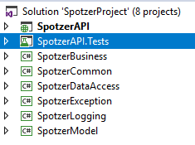

Required assignment has been prepared on Visual Studio 2017 and coded with Web API on .NET Framework 4.6. Also some .net packages has been downloaded from Nuget Management such as Log4Net, Newtonsoft JSON

**Controller**

There is one controller as ApplyOrderController. The controller coded with Post method and it gets one parameter named “partnerOrder” as PartnerOrderModel. Requests will be prepared as FromBody.

Sent informations will be json format and after sent, there will be a model validation. For example there is a required area, it means this is “must” information. The other validation control is string length. For example “Partner” is defined as one character, if the message is two characters, there will be error message.

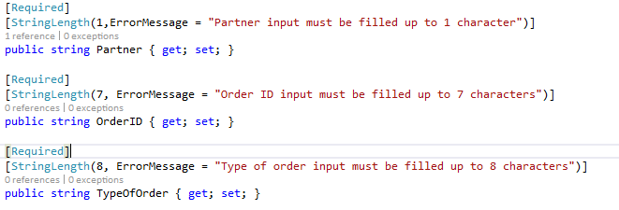

**Business**

On the business layer, I used factory pattern for determine object for each partner. It determines in ApplyOrderFactory class and determined partner type will be return a class such as ParterA, PartnerB and each partner class has own business logic according to requirements.

**ErrorException**

There is a new errorException class which is inherited from Exception library belongs to .NET Framework. For assignment I keep it simple. We can improve the error exception management for each event such as Http Error, Binding Error, Logging Error or Database Error

**Logging**

I used log4net. I logged every request, every response and every error on API Controller in a text file named “SpotzerLogFile.log” in SpotzerAPI Folder. Log4net appender can be switch to ADO Appender (I didn’t add) when you add log4net ADO appender parameters in web.config file in SpotzerAPI project. I used file appender.

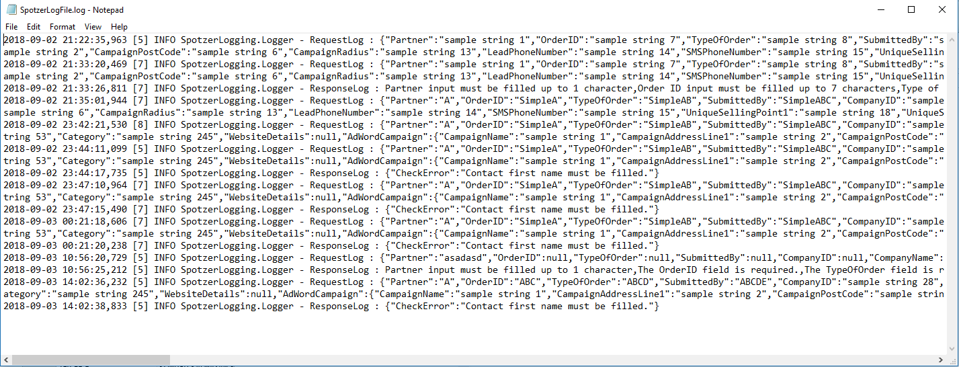

**Model**

I created 3 models such as PartnerOrderModel, PaidSearchModel, WebsiteModel as root. PartnerOrderModel includes general information of customers. WebSiteModel includes website order information. Also this model includes website detail information in WebsiteModel. The same rule applied in PaidSearchModel.

**UnitTest**

There are 8 unit test methods In SpotzerAPI.Test. It runs successful messages and failed messages. For failed messages, there is validation method for validate models.

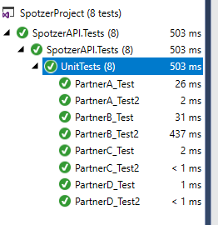

**Common**

It created for common objects such as Enums, Constraints, etc. But there is no object.

**DataAccess**

It created for repository pattern for database processes. But it’s empty.

**How It Works ?**

Be sure SpotzerAPI set as startup project in Visual Studio 2017, then run the project. There will be start an internet explorer page which is show 403.14 error. It is not problem for working API.

After that, we need use a third party http listener application such as Fiddler or Postman. I used Fiddler 4

On Fiddler 4, follow the steps below. Be sure enter the content type.

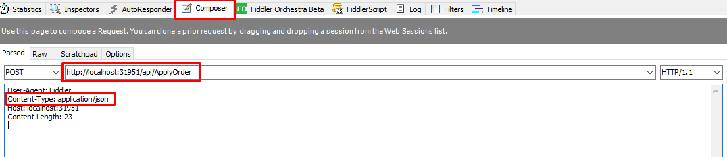

Fill the request body according to partner needs.

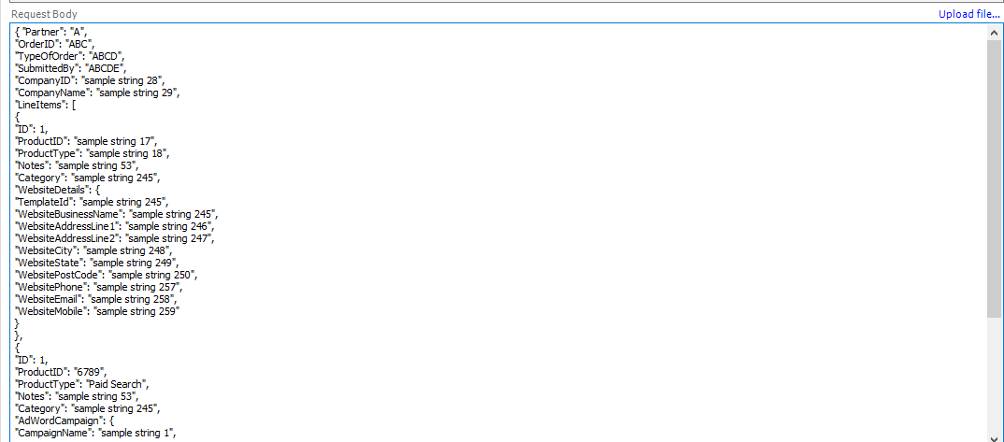

Then press “Execute” button on Fiddler

I run on debug mode.

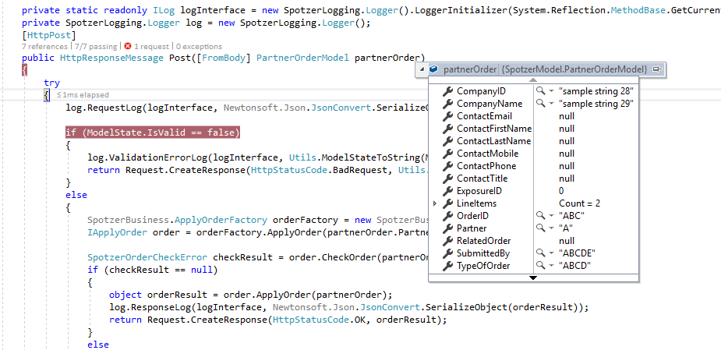

Result

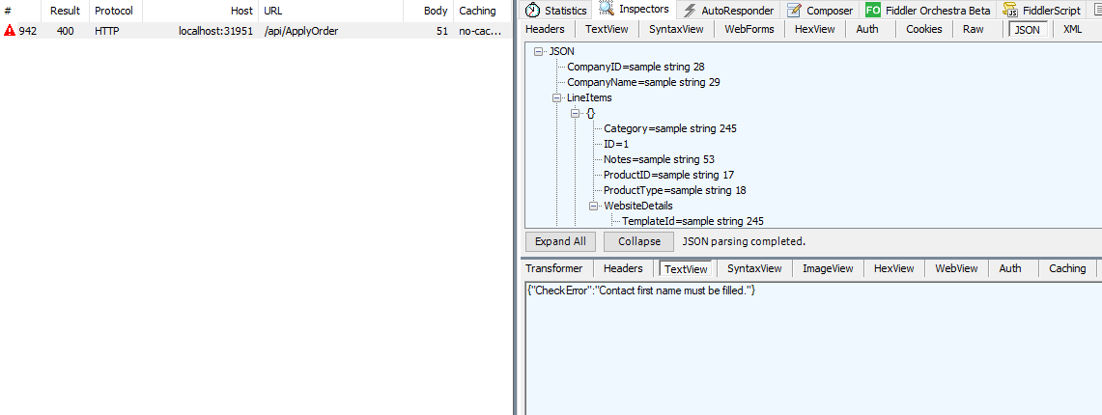

For any questions, you can send mail to me

[polatfirat@gmali.com](mailto:polatfirat@gmali.com)

Test Bu